Drop Keyword: Using this keyword we dropped column

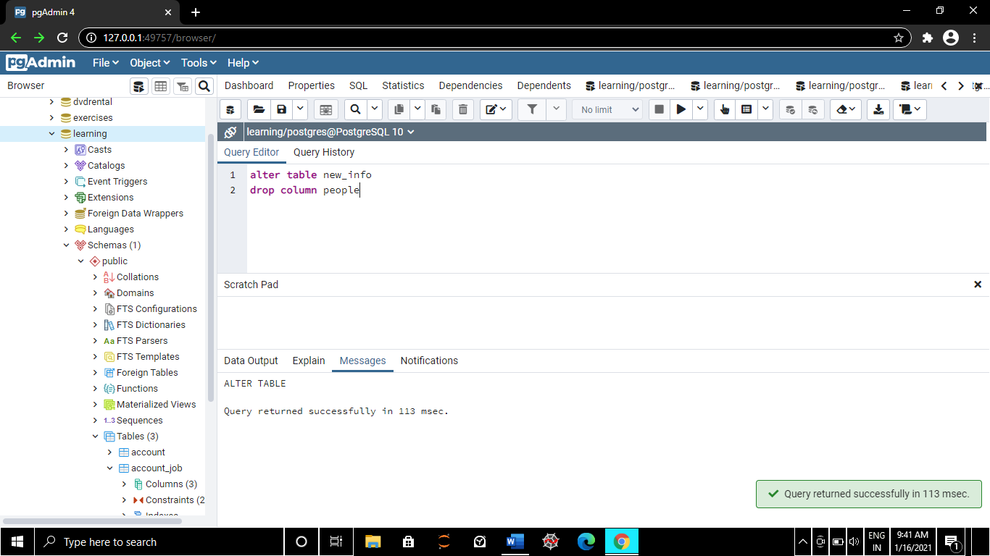

Here we are checking if column exists

